10. Illustrate the concept of inter-process communication using message queue with a c program
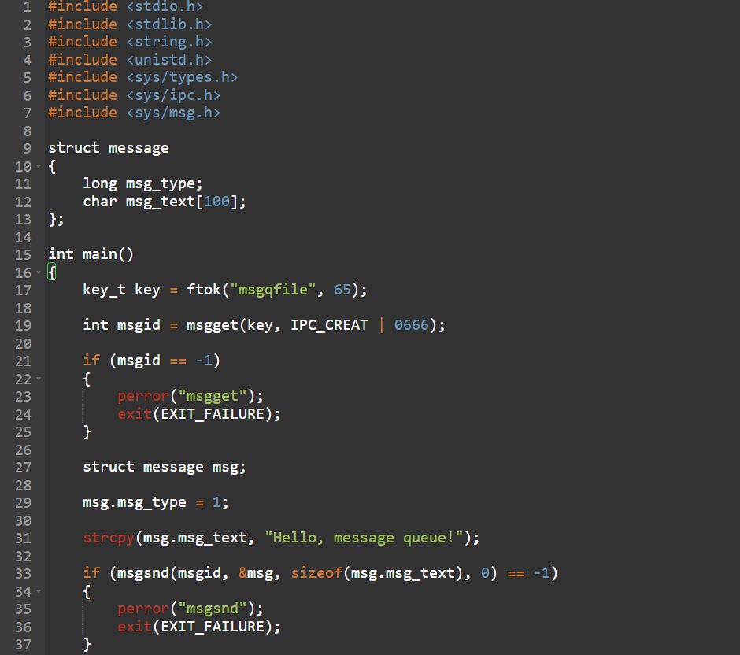
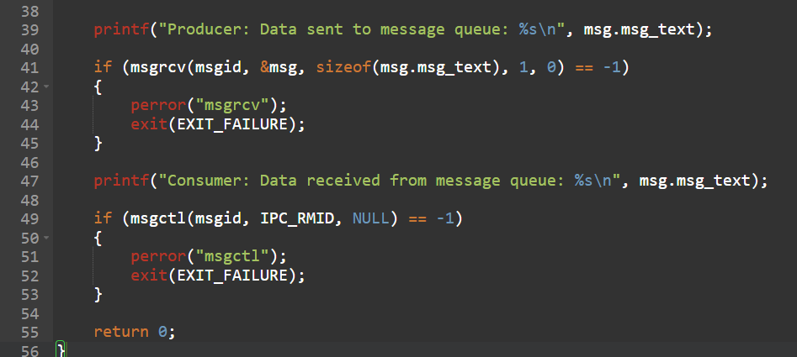

OUTPUT:
